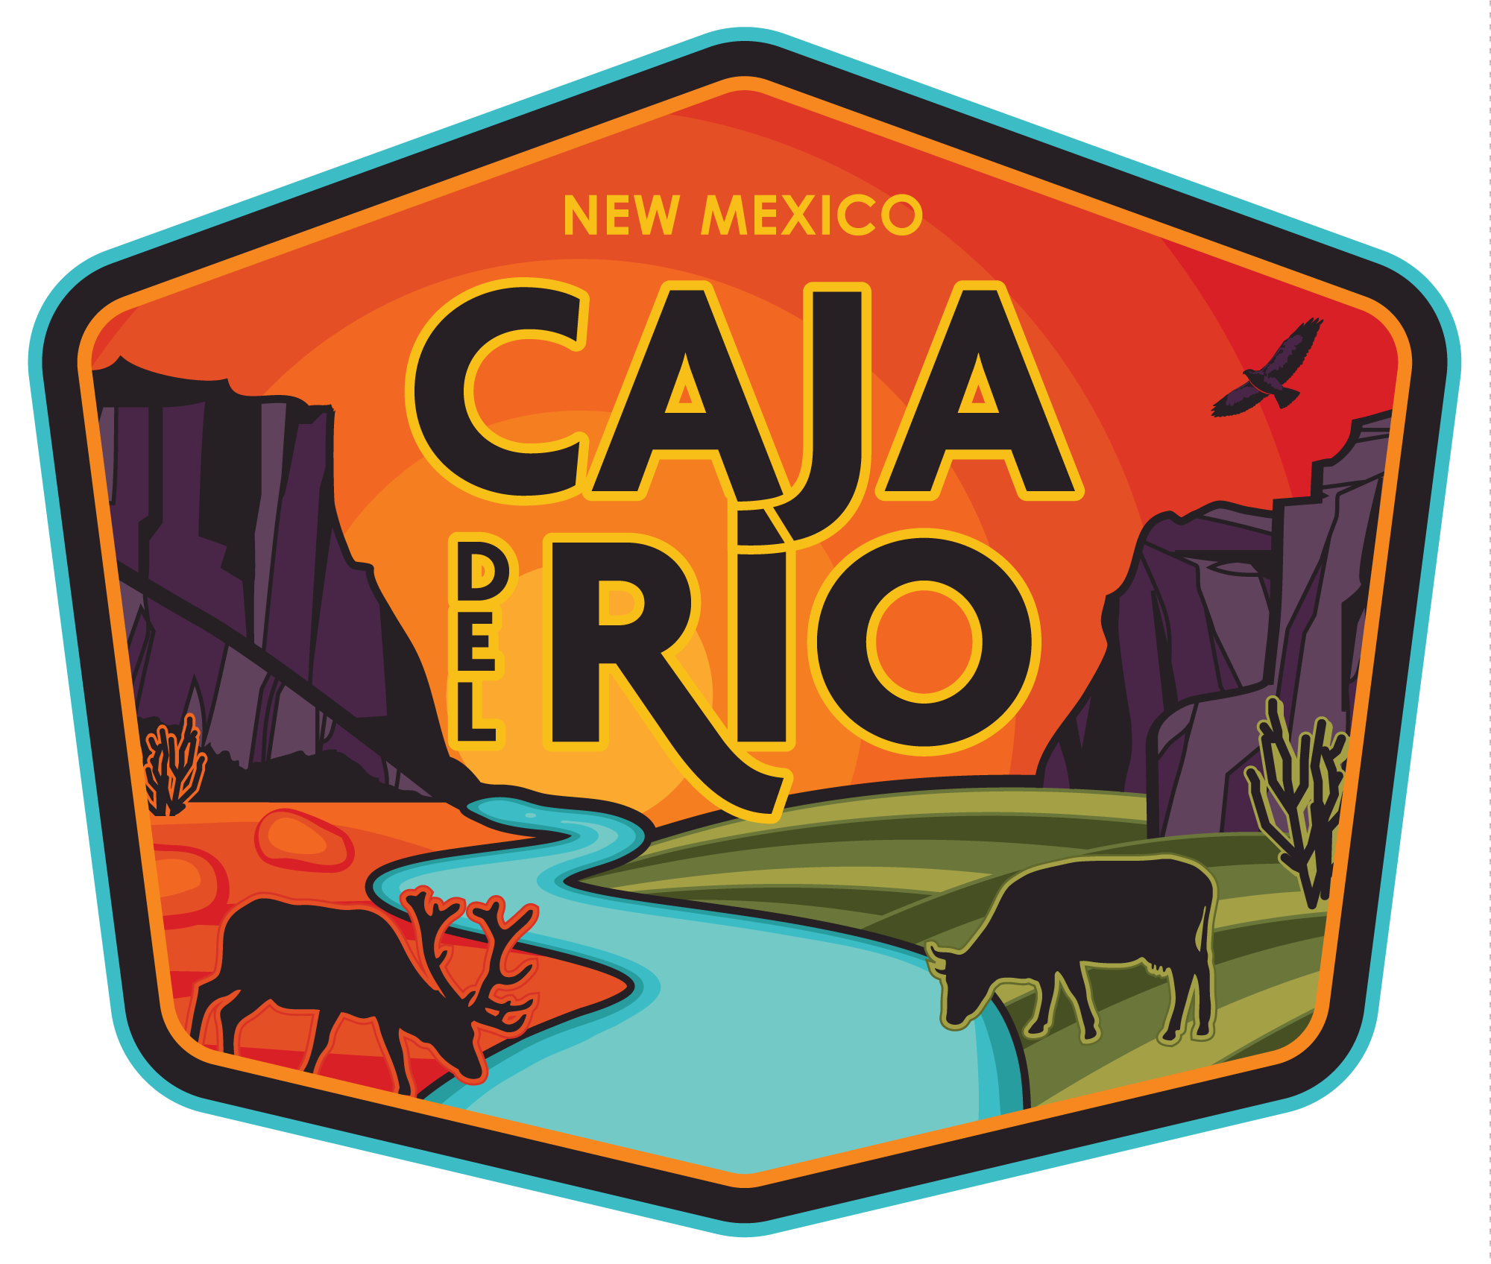
FOR IMMEDIATE RELEASE
Thursday, Mar 26, 2026
Contact:
Ben Lewinger (505) 850-9010
ben@createyourfable.com
Emily Esterson (505) 553-2671
emily@createyourfable.com
Coalition, local governments call for federal protection of Caja del Rio
SANTA FE, N.M. – A diverse group of local government officials and state legislators are advocating for the permanent protection of the Caja del Rio, a culturally and ecologically significant landscape south of Santa Fe, urging New Mexico’s congressional delegation to act now to preserve the area.
Letters of support came from Santa Fe city councilors, Mayor Michael Garcia, the majority of state legislators and Santa Fe County Commissioners in response to the demand of Tribes and local communities that the delegation act to ensure the Caja del Rio is protected and responsibly stewarded in perpetuity. In addition, the Caja del Rio Coalition, including Indigenous, Hispano, government, business, grazing permittee, faith, and conservation leaders, are calling on the delegation to introduce legislation to permanently protect the Caja del Rio.
“The Caja del Rio is treasured by my constituents,” said New Mexico Senate Majority Leader Peter Wirth (SF-25). “From members of sovereign Pueblo nations who consider these ancestral lands as part of their identity, multi-generational Hispano residents who value these lands for traditional uses, to Santa Fe residents who recreate there. This place is truly a New Mexican heirloom which deserves permanent federal protection.”
Santa Fe Mayor Michael Garcia noted the ecological importance of the area: "Spanning over 100,000 acres, the Caja del Rio represents one of the last intact high-desert landscapes adjacent to the state capital and provides critical habitat to elk, mule deer, raptors, and migratory birds. I urge support to create lasting federal legislation to permanently protect and responsibly steward the Caja del Rio."
The Caja plateau is unique in its historic, cultural, and ecological significance, as well as its recreational opportunities for New Mexico residents. Hispano and Indigenous communities have used the Caja del Rio for centuries for religious ceremonies, grazing, firewood and piñon nut gathering and hunting. The area contains significant portions of El Camino Real de Tierra Adentro, the longest Euro-American trade route, linking Mexico City to Northern New Mexico and is home to a rich ecosystem that provides essential habitat for wildlife.
“The Northern Río Grande National Heritage Area stands as a dedicated steward and advocate for the rich tapestry of culture, heritage, language, and environment of Northern New Mexico. That is why we believe it is so important to create permanent protection for the Caja del Rio,” said Anna Hansen, treasurer of NRGNHA.
In addition to conservation organizations and Pueblo, Hispano and spiritual leaders, local government officials recognized the value of preserving this culturally rich and sacred area in Northern New Mexico, which is managed by the Forest Service, the Bureau of Land Management and National Park Service. The Caja del Rio contains important sections of the El Camino Real de Tierra Adentro, historic Route 66, and the La Cieneguilla petroglyphs, in addition to prime wildlife habitat.
"As the Santa Fe County Commissioner from District 2, I remain committed to working in partnership with Tribes, Traditional Historic Communities, local governments, and our federal delegation to secure lasting, collaborative protection for the Caja del Rio,” said Lisa Cacari Stone Ph.D., County Commissioner for District 2.
“Permanent federal protection would ensure that traditional uses, local grazing practices, recreation, and community-based stewardship continue, while safeguarding this irreplaceable landscape for future generations," Cacari Stone said.
Letters of support from the State Legislature, Santa Fe County Commission, City of Santa Fe and Rio Grande Natural Heritage Area are available to view on the website.

###
The Caja del Rio Coalition is a diverse group of individuals, organizations, elected leaders, Pueblo and Hispano leaders, spiritual leaders, conservationists, outdoor recreation enthusiasts and more who all share one thing in common: a commitment to preserving the beauty, history, water and wildlife of the Caja del Rio. Together we work to ensure that the Caja del Rio will be cared for and protected for generations to come. More info at cajadelrio.org.

